**VISVESVARAYA TECHNOLOGICAL UNIVERSITY**

**“JnanaSangama”, Belgaum -590014, Karnataka.**



**LAB REPORT**

**on**

**BIG DATA ANALYTICS**

**(20CS6PEBDA)**

***Submitted by***

**Naman Singh (1BM19CS093)**

***in partial fulfillment for the award of the degree of***

**BACHELOR OF ENGINEERING**

***in***

**COMPUTER SCIENCE AND ENGINEERING**



**B.M.S. COLLEGE OF ENGINEERING**

**(Autonomous Institution under VTU)**

**BENGALURU-560019**

**May-2022 to July-2022**

**B. M. S. College of Engineering,**

**Bull Temple Road, Bangalore 560019**

(Affiliated To Visvesvaraya Technological University, Belgaum)

**Department of Computer Science and Engineering**



**CERTIFICATE**

This is to certify that the Lab work entitled “**BIG DATA ANALYTICS**” was carried out by **NAMAN SINGH (1BM19CS093),** who is a bona fide student of **B. M. S. College of Engineering.** It is in partial fulfillment for the award of **Bachelor of Engineering in Computer Science and Engineering** of the Visvesvaraya Technological University, Belgaum during the year 2022. The Lab report has been approved as it satisfies the academic requirements in respect of the course **BIG DATA ANALYTICS (20CS6PEBDA)** work prescribed for the said degree.

Name of the Lab-In charge               **Dr. Pallavi G B**

Designation Assistant Professor

Department of CSE Department of CSE

BMSCE, Bengaluru BMSCE, Bengaluru

`

**Index Sheet**

| **Sl. No.** | **Experiment Title** | **Page No.** |
| --- | --- | --- |
| **1.** | **MongoDB Lab - 1** | **4** |
| **2.** | **MongoDB Lab - 2** | **7** |
| **3.** | **Cassandra Lab - 1** | **13** |
| **4.** | **Cassandra Lab - 2** | **24** |

**Course Outcome**

| CO1 | Apply the concept of NoSQL, Hadoop or Spark for a given task |
| --- | --- |
| CO2 | Analyze the Big Data and obtain insight using data analytics mechanisms. |
| CO3 | Design and implement Big data applications by applying NoSQL, Hadoop or Spark |

**MongoDB Lab -1**

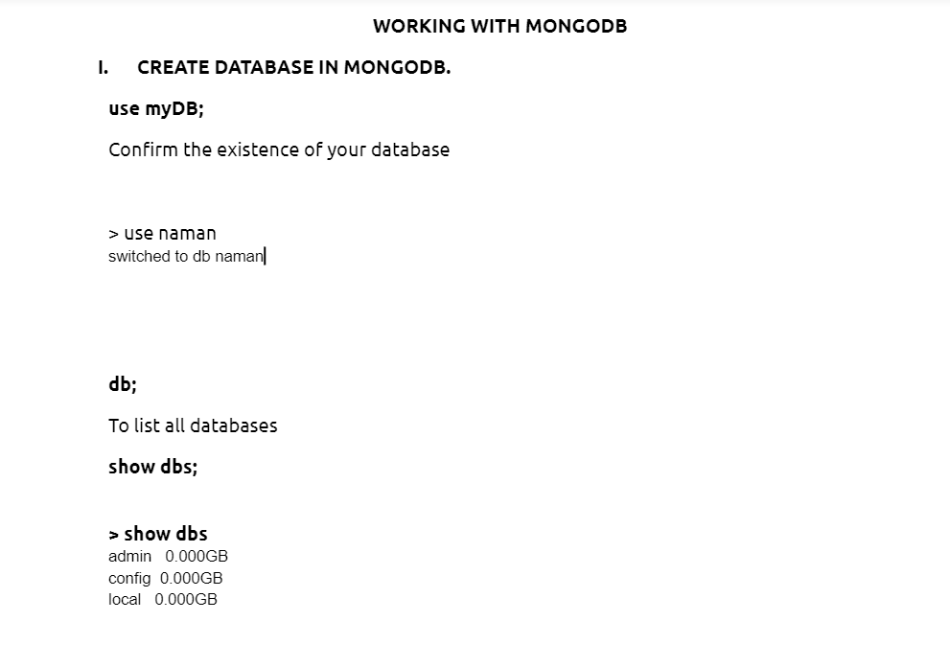

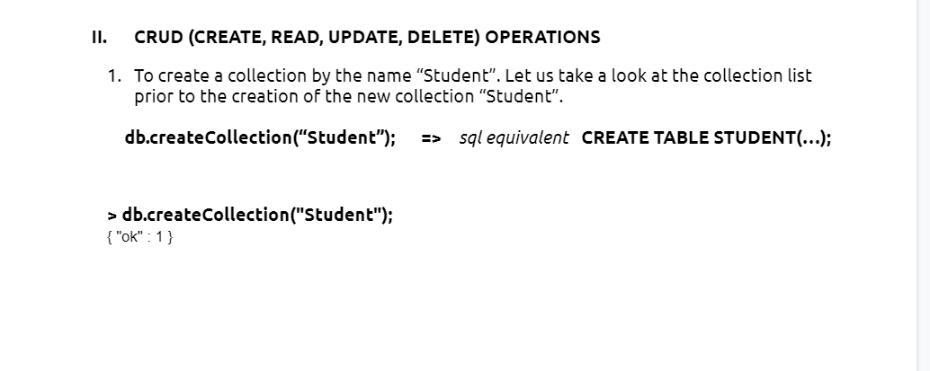

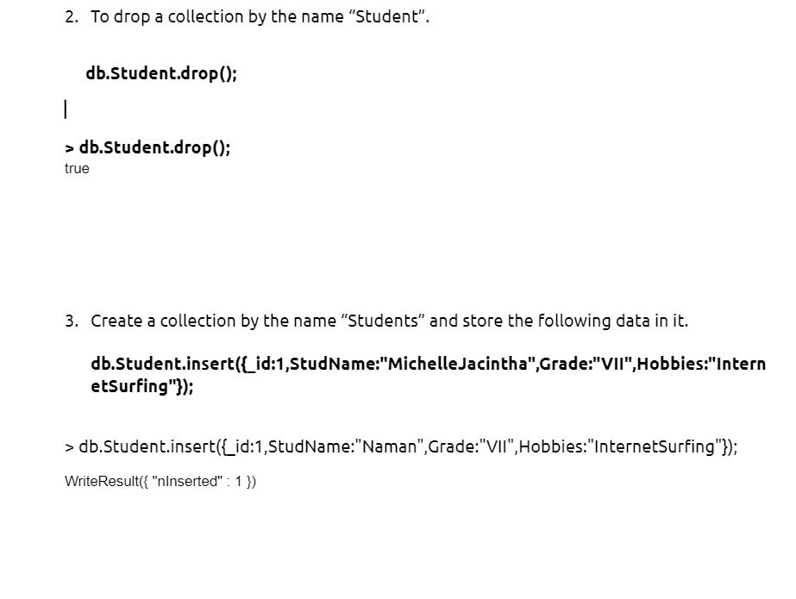

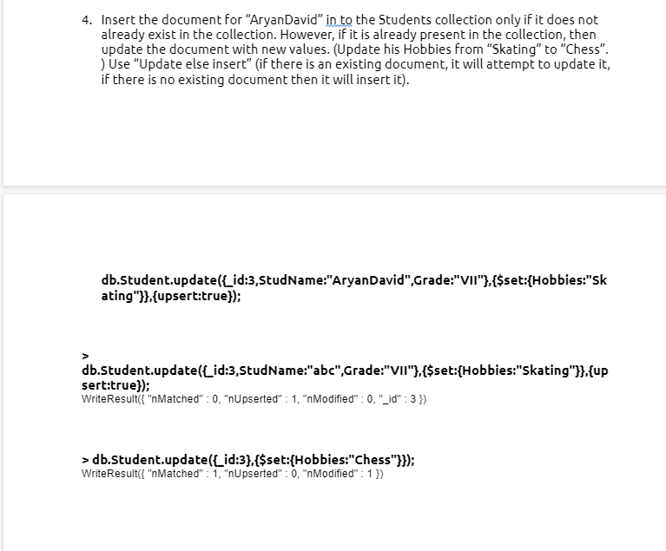

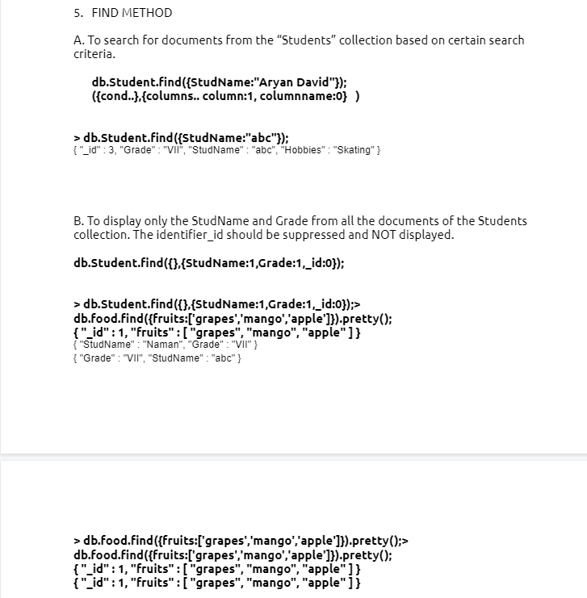

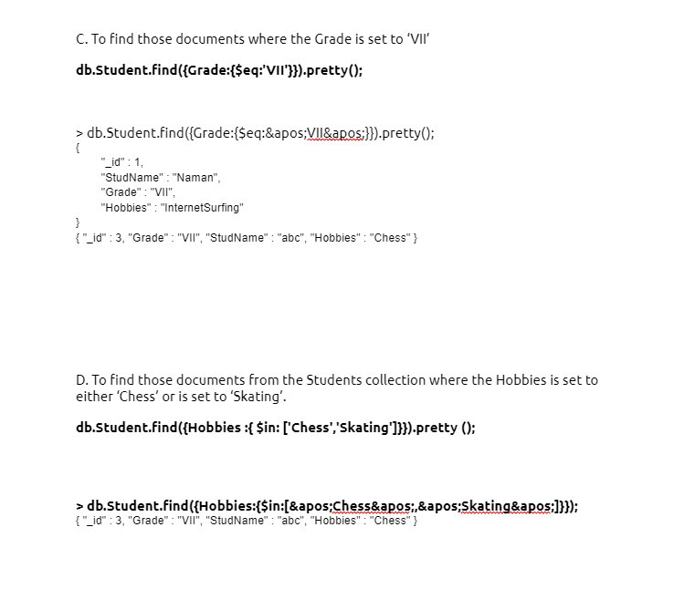

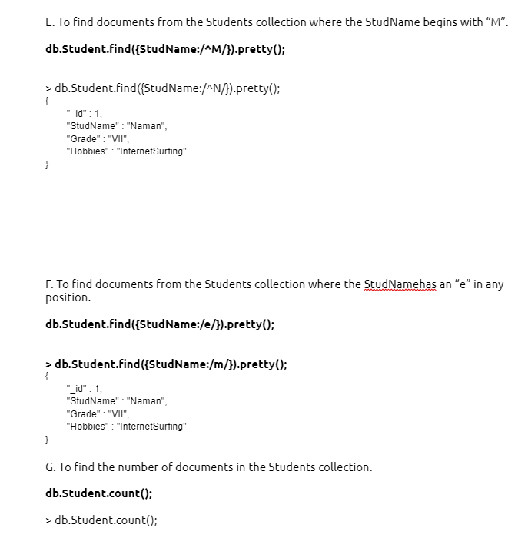

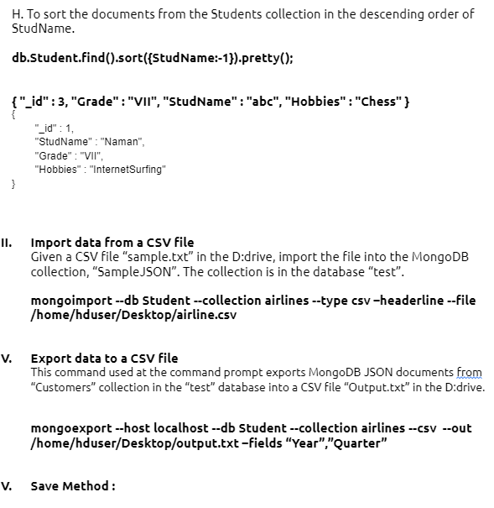

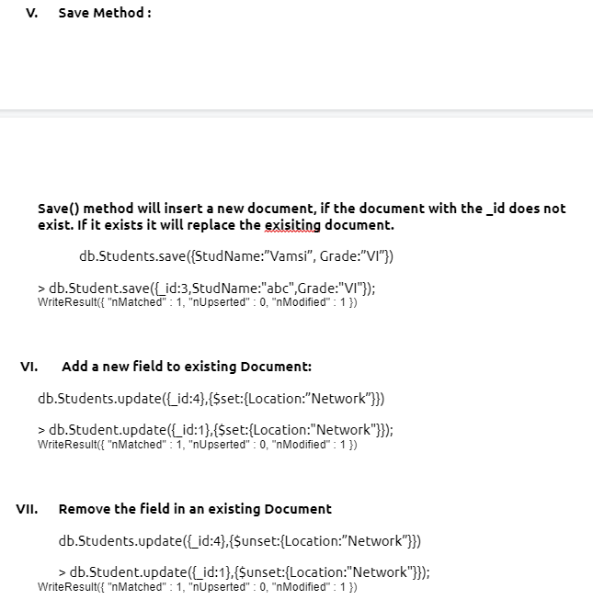

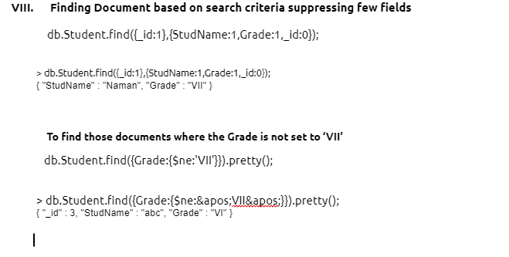



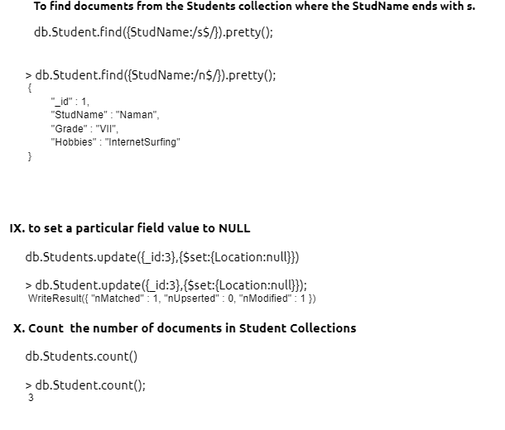

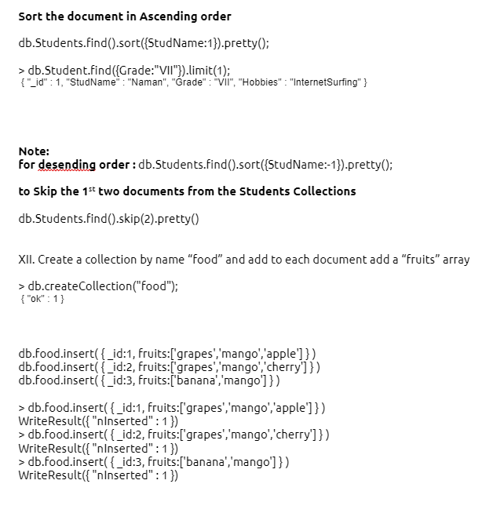

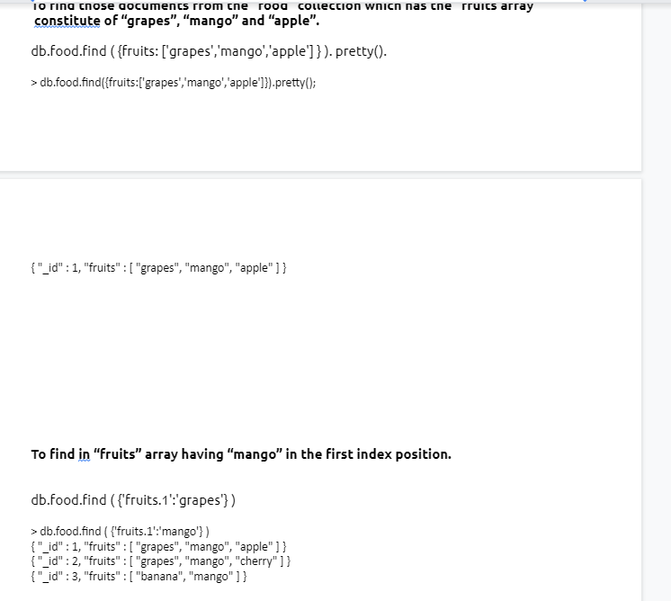

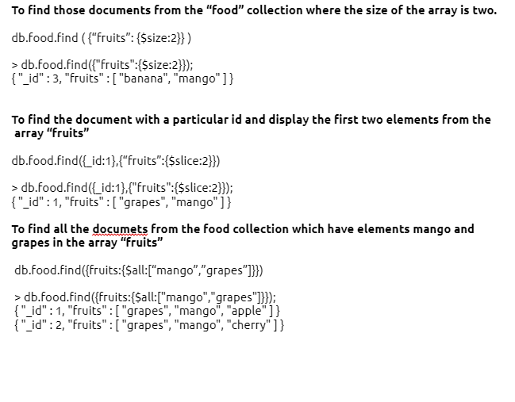

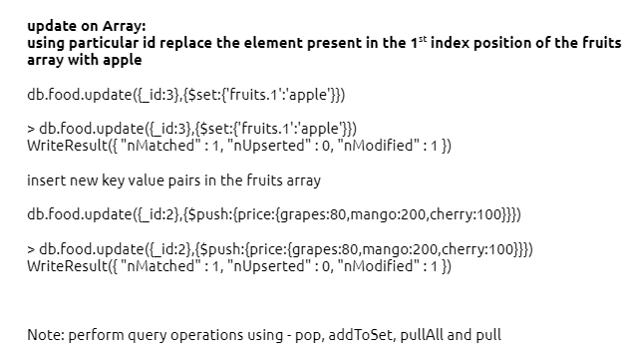



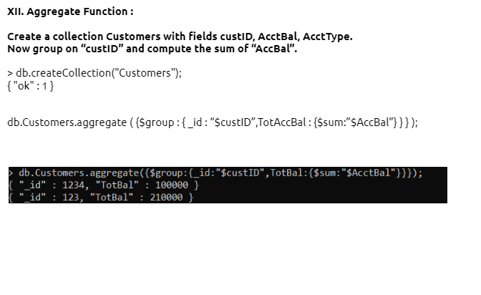

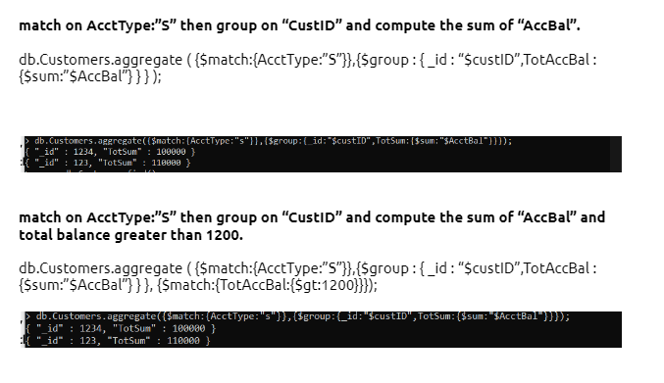



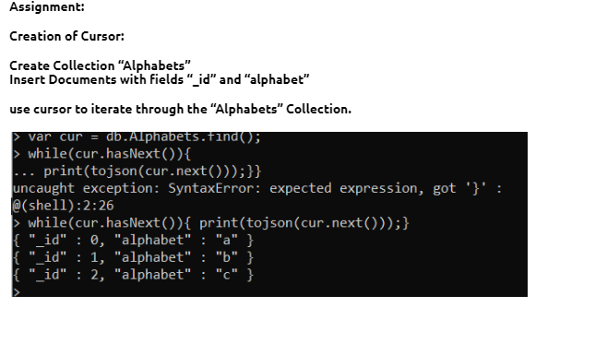

**MongoDB Lab 2: -**

1) Using MongoDB

1. Create a database for Students and Create a Student Collection (_id,Name, USN, Semester, Dept_Name, CGPA, Hobbies(Set)).
2. Insert required documents to the collection.
3. First Filter on “Dept_Name:CSE” and then group it on “Semester” and

compute the Average CPGA for that semester and flter those documents where the “Avg_CPGA” is greater than 7.5.

1. Command used to export MongoDB JSON documents from “Student” Collection into the “Students” database into a CSV fle “Output.txt”.

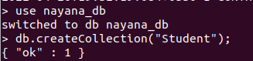

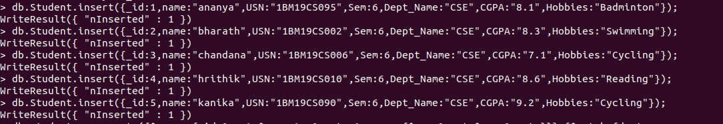

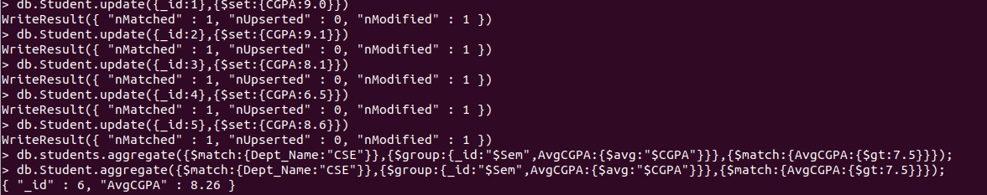



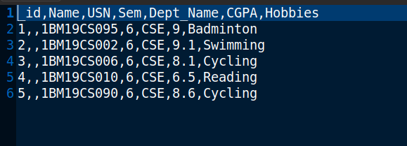

2)Create a mongodb collection Bank. Demonstrate the following by choosing felds of your choice.

1. Insert three documents
2. Use Arrays(Use Pull and Pop operation)
3. Use Index
4. Use Cursors
5. Updation

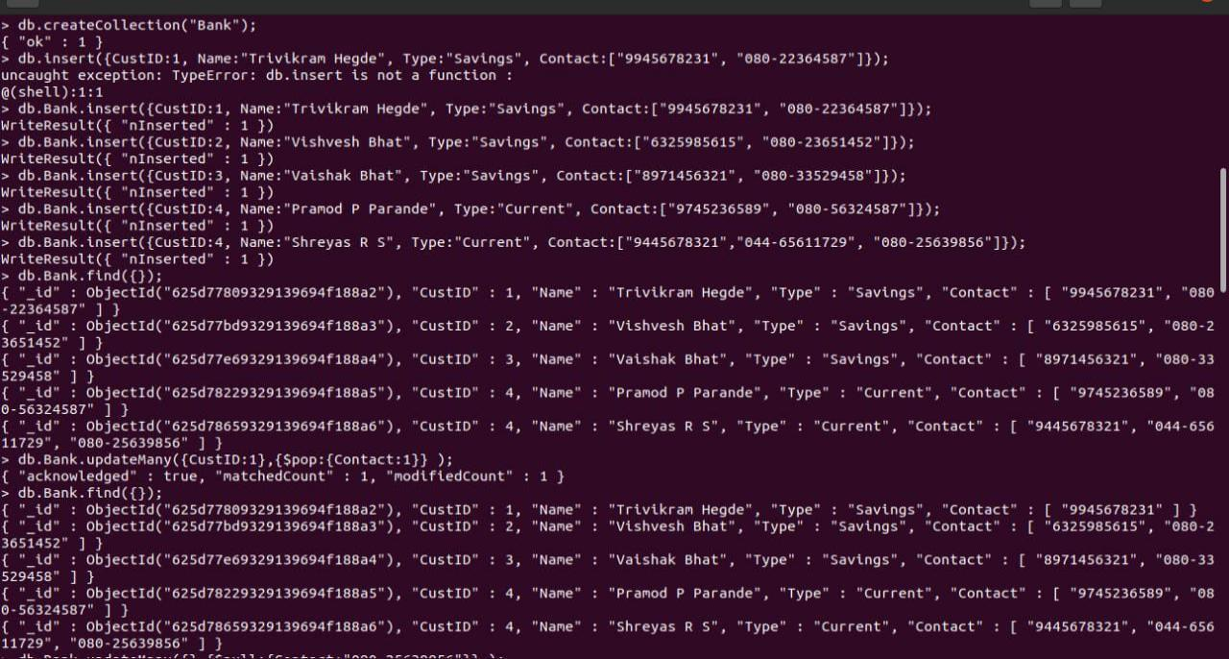

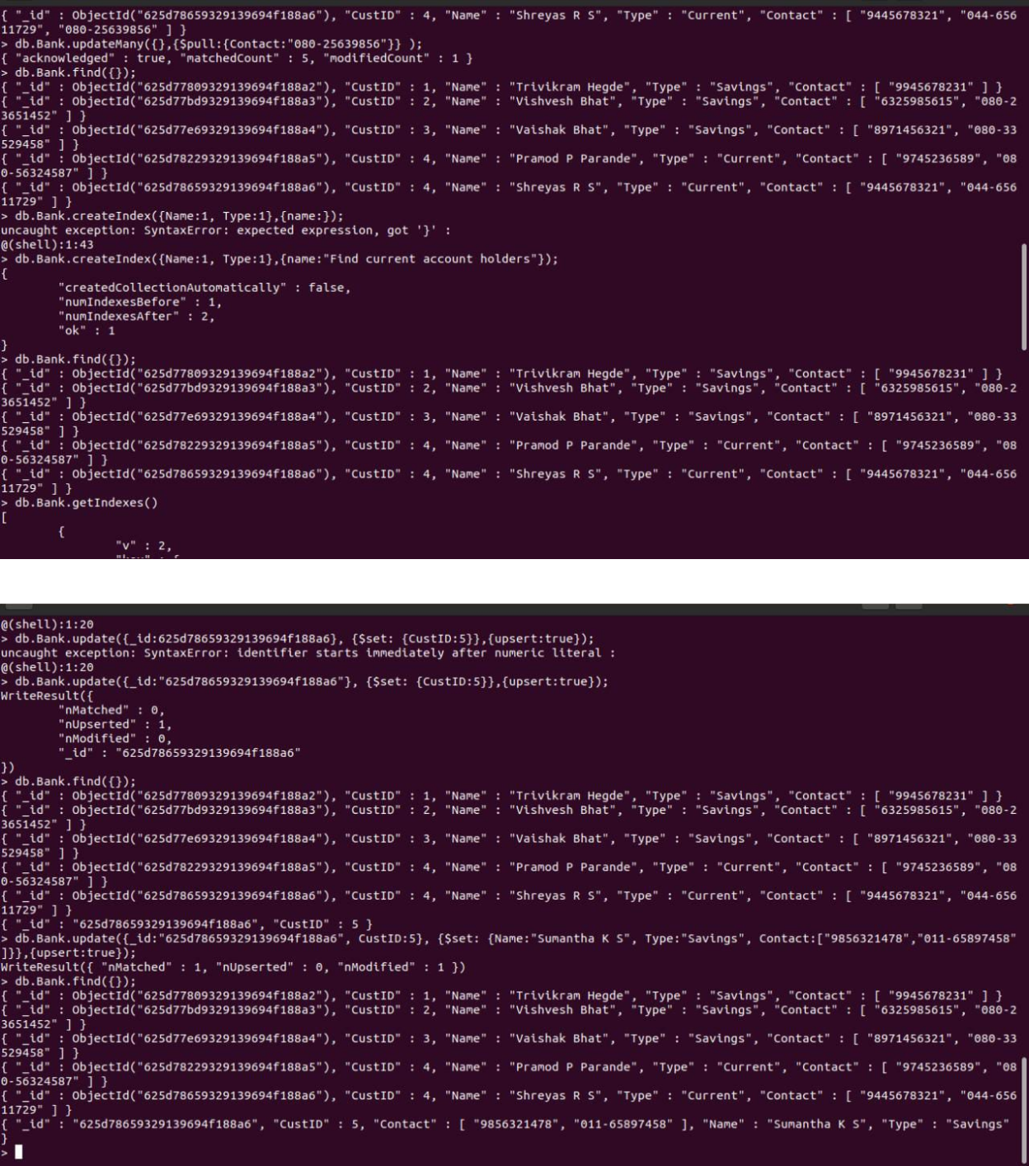

1) Using MongoDB,

1. Create a database for Faculty and Create a Faculty Collection(Faculty_id, Name, Designation ,Department, Age, Salary, Specialization(Set)).
2. Insert required documents to the collection.
3. First Filter on “Dept_Name:MECH” and then group it on “Designation” and

compute the Average Salary for that Designation and flter those documents where the “Avg_Sal” is greater than 650000. iv) Demonstrate usage of import and export commands

Write MongoDB queries for the following:

1)To display only the product name from all the documents of the product collection.

2)To display only the Product ID, ExpiryDate as well as the quantity from the document of the product collection where the _id column is 1.

3)To fnd those documents where the price is not set to 15000.

4)To fnd those documents from the Product collection where the quantity is set to 9 and the product name is set to ‘monitor’.

5)To fnd documents from the Product collection where the Product name ends in ‘d’.

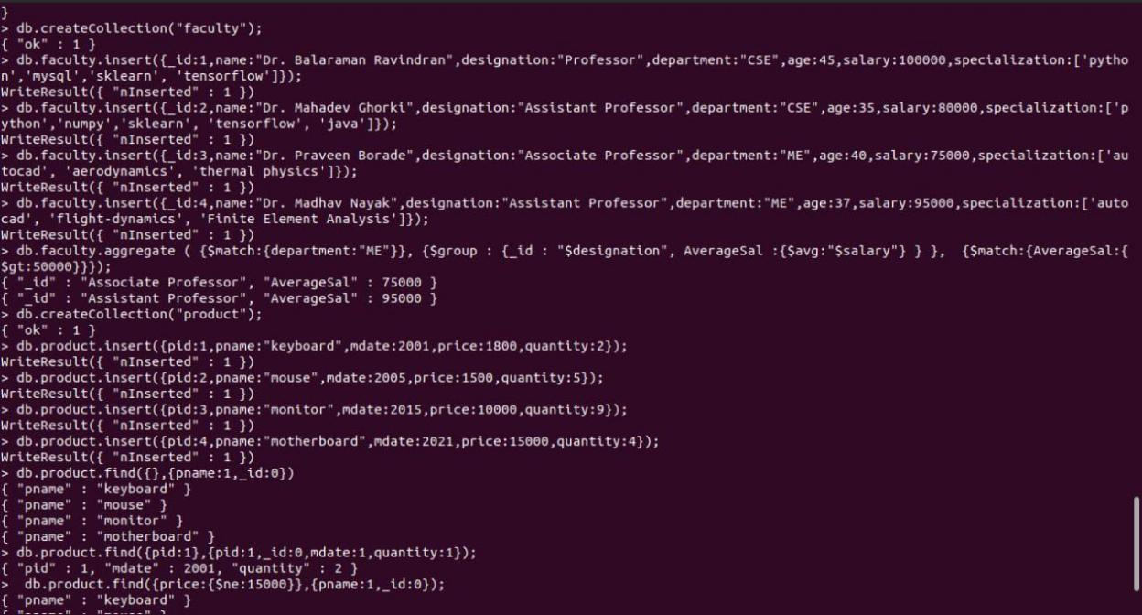

| 3)Create a mongodb collection Hospital. Demonstrate the following by choosing felds of | |
| --- | --- |
| choice. | |
| 1. | Insert three documents |
| 2. | Use Arrays(Use Pull and Pop operation) |
| 3. | Use Index |
| 4. | Use Cursors |
| 5. | Updation |

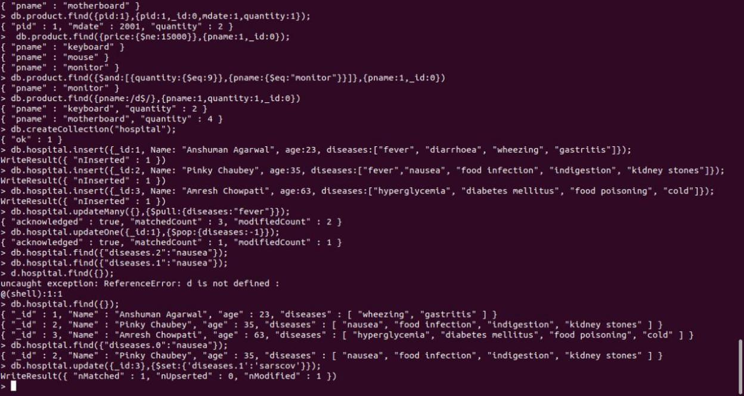

**Cassandra Lab Program 1: -**

Perform the following DB operations using Cassandra.

1. Create a key space by name Employee

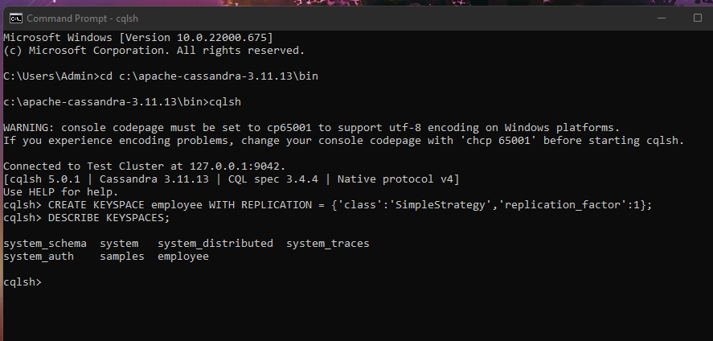

2. Create a column family by name Employee-Info with attributes Emp_Id Primary Key, Emp_Name,

Designation, Date_of_Joining, Salary, Dept_Name

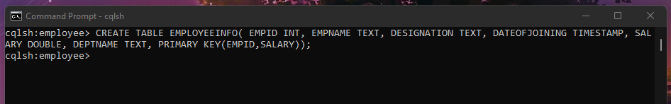

3. Insert the values into the table in batch

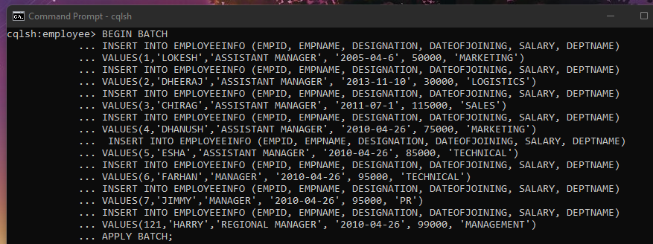

4. Update Employee name and Department of Emp-Id 121

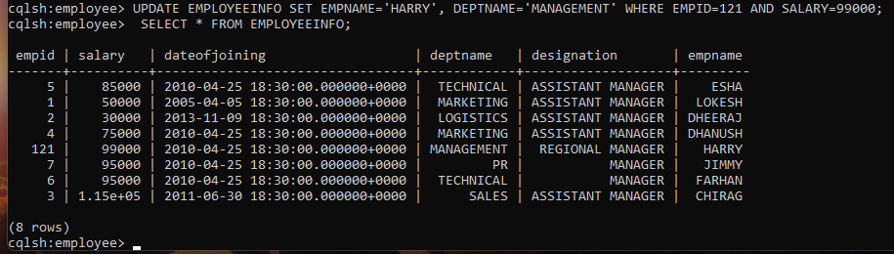

5. Sort the details of Employee records based on salary

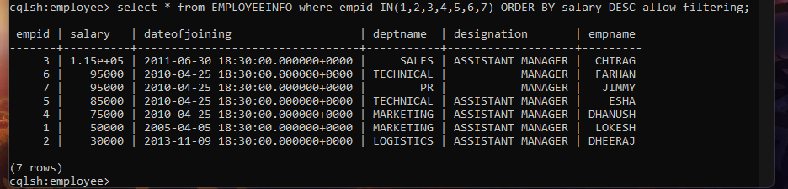

6. Alter the schema of the table Employee_Info to add a column Projects which stores a set

of Projects done by the corresponding Employee.

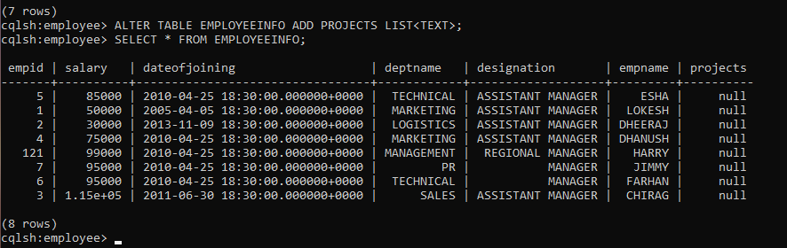

7. Update the altered table to add project names.

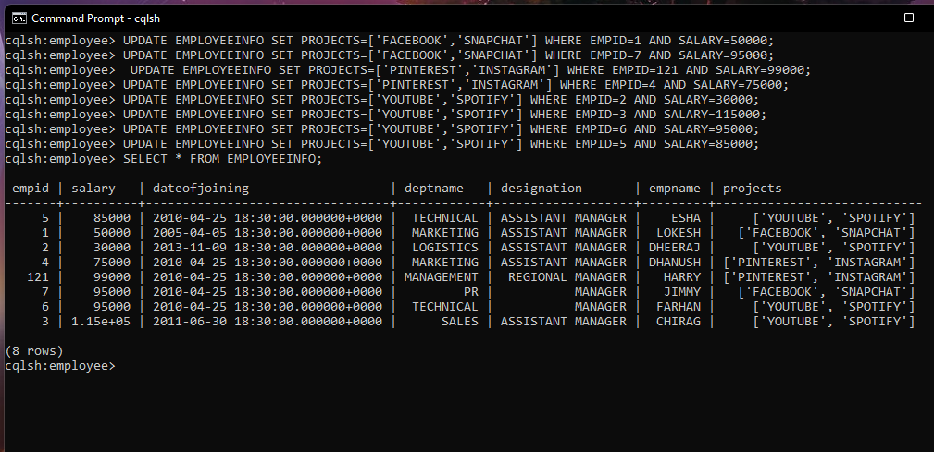

8. Create a TTL of 15 seconds to display the values of Employees.

//BEFORE 15 seconds

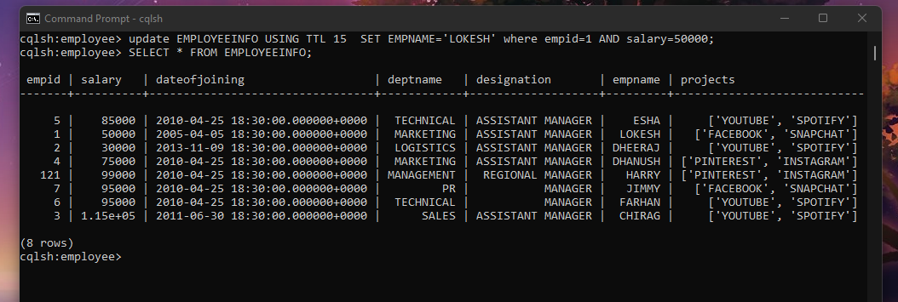

**Cassandra - Lab 2**

